Physics
Written Paper 2BPHY
Question/Answer Booklet

Student Number: In figures

In words

Student name: ______ANSWER KEY__________ Teacher name: _________________

Time allowed for this paper
Reading time before commencing work: Ten minutes
Working time for paper: Three hours

Material required/recommended for this paper

To be provided by the supervisor
This Question/answer booklet; Formulae and constants sheet

To be provided by the candidate
Standard items: pens, pencils, eraser or correction fluid, ruler, highlighter

Special items: scientific non-programmable calculator

Important note to candidates
No other items may be taken into the examination room. It is your responsibility to ensure that you do not have any unauthorised notes or other items of a non-personal nature in the examination room. If you have any unauthorised material with you, hand it to the supervisor before reading any further.

All calculations are to be set out in detail. Marks may be awarded for correct equations and clear setting out, even if you cannot complete the calculation. Express numerical answers to two (2) or three (3) significant figures and include units where appropriate.
Student Marks
Section |  | Percentage of paper | Maximum mark | Student Mark
Section One  15 - 20 questions | Short Answer  35-45% | 39 | 50
Section Two  4 – 7 questions | Problem Solving  45-55% | 52 | 67
Section Three  1 -2 questions | Comprehension  5-15% | 9 | 11
Overall |  |  | 2
Student total Mark out of 130
Student Percentage
Structure of this paper

Note:
Section of exam | Suggested working time | Number of questions | Number of questions to be attempted | Marks available
Section One | 65 minutes | 19 | all | 50
Section Two | 90 minutes | 6 | all | 67
Section Three | 15 minutes | 1 | all | 11
Overall | Checking  10 minutes |  |  | 2
 |  |  | [Total marks] | 130
The ‘overall’ section represents marks allocated to appropriate use of units in the final answers to numerical problems.

Instructions to candidates

- The rules for the conduct of WACE examinations are detailed in the Student Information Handbook. Sitting this examination implies that you agree to abide by these rules.

- Answer all questions in the spaces provided in this Question/Answer Booklet.

- A blue or black ballpoint or ink pen should be used except for graphs were a pencil should be used.
Section one: Short answer 50 marks

This section has nineteen (19) questions. Answer in the spaces provided.

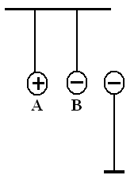
- Three charged spheres are placed near each other and held. Spheres A and B are free to move but sphere C is in a fixed position. Once released, describe the initial motion of A and B. (2 marks)

The negatived will move right towards the positive [1 mark]
The positive will move towards the negative and probably touch
[1 mark]

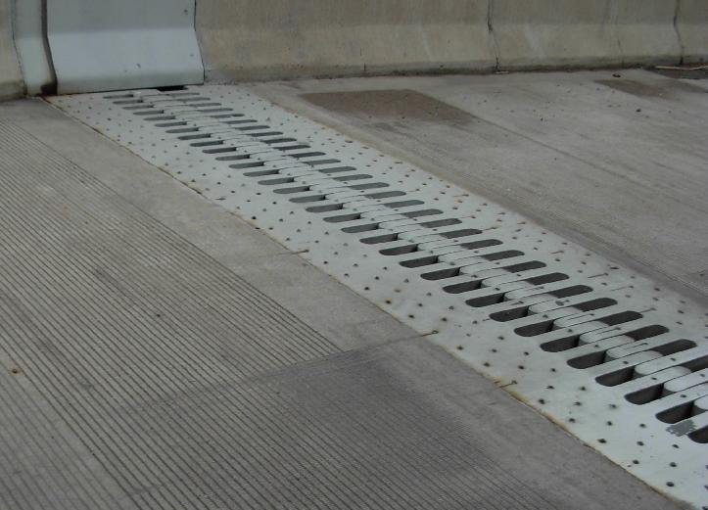
- The picture shows an expansion joint in a bridge. What is the purpose of the joint, why is it necessary and how does it work? (2 marks)

During warmer temperatures the kinetic energy of the particles of the bridge increase the bridge therefore expands [1 mark]

When the bridge expands there is room for the joints to expand. [1 mark]

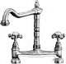
- A single outlet connected to both taps over a kitchen sink is supplied with cold water at 8.0⁰C and hot water at 64⁰C. Two students are measuring the flow and finds out that the cold water tap is giving a flow of 8.0 litre min⁻¹. They then adjust the hot water tap to give a total flow rate of 14.0 litre min⁻¹ through the outlet. One student then measured the temperature of the warm water. What was this temperature?
(2 marks)
mcΔT (hot water) = mcΔT (cold water)
as specific heat, c, is contant
8(T_{f} – 8) = 6(64 – T_{f}) [1 mark]
8T_{f} – 64 = 384 – 6T_{f}
8T_{f} + 6T_{f} = 384 + 64
14T_{f} = 448
T_{f} = 32 ⁰C [1 mark]

- Water is the main liquid used in car cooling systems. Explain, in terms of physics principles, why water is used. (3 marks)

Water has a high specific heat [1 mark]
Water can easily flows around cooling system [1 mark]
Water can absorb a large amount of energy before increasing temperature [1 mark]

- Keaton and Ashlee are listening to several of Ashlee’s latest CDs on a portable stereo system during lunch. The stereo system runs off four 1.50 V cells connected in series. The total resistance of the stereo when used to play music is 24.0 Ω. How much current does the stereo draw from the cells assuming that the potential difference from the four cells is added together? (3 marks)

V = 1.5 x 4 [1 mark]
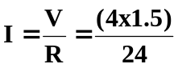 [1 mark]
I = 0.25 A [1 mark]

- Two students are studying for their Physics Examination. How much energy would a kettle needed to supply in order to heat 565 mL of water initially at 18⁰ C to 90⁰ C to make the students a cup the tea? (2 marks)

Q = mcΔT
= 0.5 x 4180 x (90 – 18) [1 mark]
= 150480
Q = 1.50 x 10⁵ J [1 mark]

- A research assistant was trying to determine the latent heat of fusion of a new material. He recorded both the energy added and the temperature of the material. The graph below shows his results.
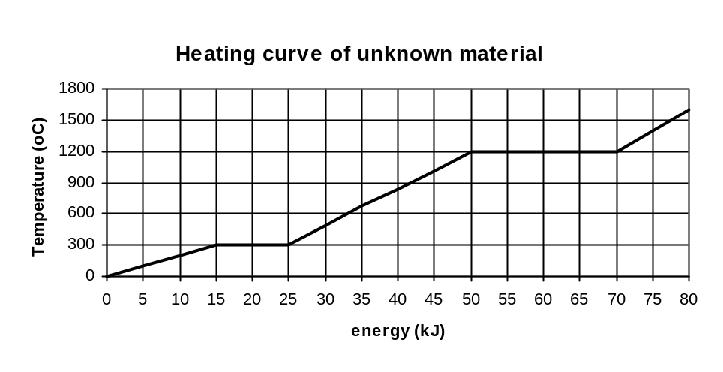
He determined that the latent heat of fusion for this material was 2.00 x 10⁵ J kg⁻¹. What mass of material was he using? (3 marks)

Q for latent heat = 10 kJ [1 mark] Q = mL
10 000 = m x 2.00 x 10⁵ [1 mark]
m = 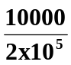
m = 0.0500 kg [1 mark]

- At University, a student was trying to determine the latent heat of a substance. She found that 9.84 x 10⁵ J of energy was required to change 0.600 kg of the substance from its liquid state a boiling point to a gas at the same temperature? Calculate the latent heat of vaporization for the substance.
(2 marks)

Q = mL
9.84 x 10⁵ = 0.600 x L
L = 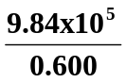 [1 mark]
L = 1640000

L = 1.64 x 10⁶ Jkg⁻¹ [1 mark]

- a. The diagram on the right shows a form of heat transfer. Name this form of heat transfer, and explain the physics about how it occurs. (3 marks)

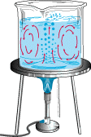
Convection and occurs in fluids (gases and liquids) [1 mark]

Heat energy increases E_{k} of molecules [1 mark]

Particles move faster and further apart so become less dense and rise up
When cooled, less E_{k} so becomes more dense and sinks [1 mark]

- Name a natural phenomena that is a result of this form of heat transfer. (1 mark)
Convection currents or any other appropriate phenomena
- In non-ohmic resistors, the resistance increases with an increase in temperature of the conducting material. Using your understanding of current and the kinetic theory, explain why the resistance increases. (3 marks)

Current – flow of electrons [1 mark]

Increase temp results in particles of conductors moving faster [1 mark]

Harder for electrons to move through conductor so more resistance. [1 mark]

- Tom was given four 3.00 Ω resistors. Draw a diagram below to show how he could connect the four resistors to give a total resistance of 4.00 Ω. (2 marks)

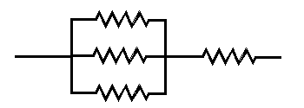

- Draw field lines around the following charged particles. (3 marks)

a. [1 mark]  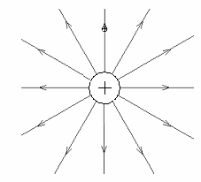 | b. [2 marks]  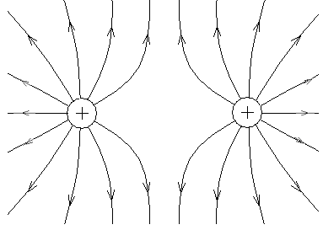

- A local Power Station converts heat into electrical energy with an efficiency of 38%. The station produces electrical energy at a rate of 3.00 x 10⁸ W from burning coal. The coal used produces 2.00 x 10⁷ J of heat per kg when it burns completely. If 1.00 W = 1.00 Js⁻¹, calculate the mass of coal burnt each day. (3 marks)

Energy produced per day = 3.00 x 10⁸ x 60 x 60 x 24
= 2.592 x 10¹³ J [1 mark]

Only 38% efficient, need = 2.592 x 10¹³ x 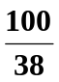
= 6.82105 x 10¹³ J [1 mark]

Mass of coal = energy needed / energy produced per kg
= 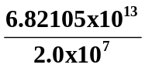
= 3410526
= 3.41 x 10⁶ kg [1 mark]

- A data logger is being used to collect data for an experiment that needs to run for 24 hours. The average current carried by the sensor system is 0.025 A and the effective sensor resistance is 20.0 kΩ. Calculate the heat energy dissipated in the system during the 24 hour period. (3 marks)

t = 24 x 60 x 60 energy = work = VIt
= 86400 s
I = 0.025 A W = VIt
R = 20 x 10³ Ω W = (0.025 x 20 x 10³) x 0.025 x 86400 [1 mark]
W = 1080000
V = IR
Energy = 1.08 x 10⁶ J [1 mark]
[1 mark]

- Ice making and dispensing machines are part of some expensive fridges. In one particular fridge, 1.50 kg of water enters the insulated compartment at 15.0 ⁰C and needs to be cooled to produce ice cubes which are at -5.00 ⁰C.
  - How much energy does the fridge remove from the water for this to occur? (3 marks)

Q = (1.5 x 4180 x 15) + (1.5 x 3.34 x 10⁵) + (1.5 x 2100 x 5] [2 marks]

Q = 94050 + 501000 + 15750

Q = 610800

Q = 6.11 x 10⁵ J [1 mark]

  - The fridge is connected to the 2.40 x 10² V power supply and receives 2.00 A of current. How long will the ice cubes take to make? (If you couldn’t obtain an answer from part (a) then use 6.00 x 10⁵ J) (2 marks)

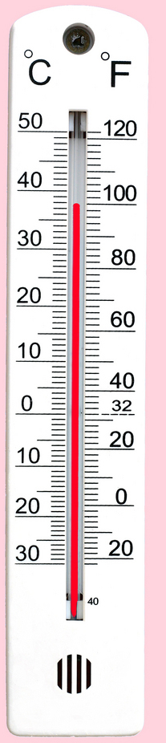
Q = VIt
610800 = 240 x 2 x t [1 mark]
t = 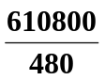
t = 1272.5

t = 1.27 x 10³ s [1 mark]

- The weather thermometer on the right is used to show the temperature in degrees Celsius and Fahrenheit.

a. What is the reading in degrees Celsius on the thermometer?
38 ⁰C [1 mark]
b. What is the absolute error of the reading?
±0.5 ⁰C [1 mark]
- A child’s toy robot requires 4.50 V to run. The batteries supply a current of 3.00 x 10² mA and a power output of 1.35 W. Calculate the electrical resistance of the robot. (3 marks)

I = 0.300 A [1 mark] P = I²R
1.35 = (0.30)² x R [1 mark]
R = 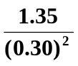
R = 15.1 Ω [1 mark]

- Pith balls are small foam balls that can hold a charge. Two statically charged pith balls will exert a force on each other due to the electrostatic repulsion or attraction. As you would expect, the magnitude of the force depends on the charge on each sphere as well as how far apart they are. This is known as Coulomb’s Law and the relationship is:

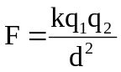 where: q₁ and q₂ = charges on pith balls in coulombs (C)
d = distance separating charges from centre to centre of charges (m)
k = constant: 9.0 x 10⁹ N m² C⁻²
F = force between charges in newtons (N)

A force of 1.07 x 10⁻¹ N attraction is acting on two small spheres 6.50 cm apart. If one has a charge of +10.0 x 10⁻⁹ C, what is the other charge? (3 marks)

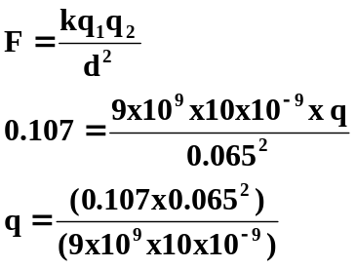 [1 mark]
q = 5.02 x 10⁻⁶ C [1 mark]
But as a force of attraction, actual charge = -5.02 x 10⁻⁶ C [1 mark]

Section two: Problem-solving 67 marks

This section has seven (7) questions. Answer in the spaces provided.

- 1. [14 Marks]

A university student was heating a 9.45 kg sample of a solid material in an insulated container which had an electrical heating coil which supplied heat at a rate of 365 W.

He measured the temperature of the substance every minute and the graph below shows the change in temperature over a 12.0 minute period.
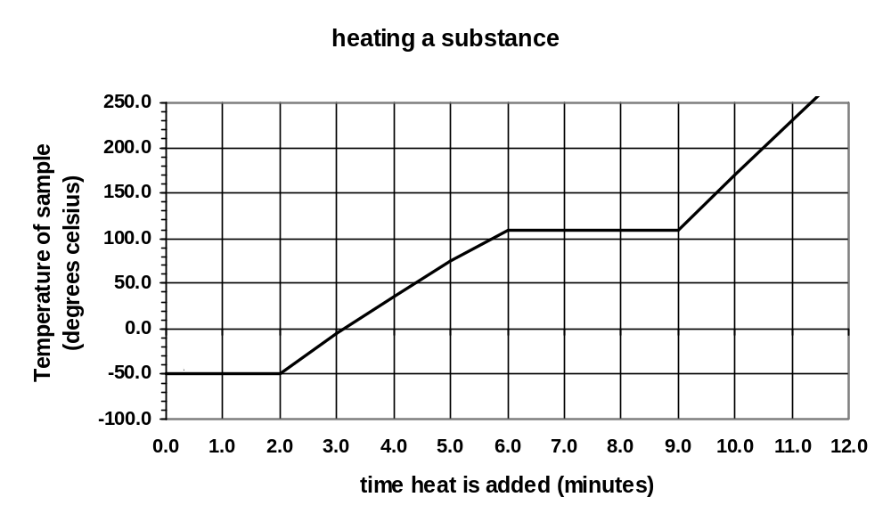
a. What is the melting temperature of the solid? (1 mark)

-50 ⁰C [1 mark]

b. What phase(s) is/are present between points C and D on the graph? (1 mark)

liquid and gas [1 mark]

c. Once the evaporation point was reached, how long did the solid take to become completely gaseous? (1 mark)

3 minutes [1 mark]

- d. How much heat energy was absorbed while the liquid was evaporating? (3 marks)

t = 3 x 60 E = Q = Pt
= 180 s = 365 x 180 [1 mark]
[1 mark] energy = 65700
= 6.57 x 10⁴ J [1 mark]

e. Calculate the latent heat of evaporation for the substance. (2 marks)

Q = mL
65700 = 9.45 x L [1 mark]

L = 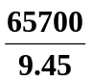
L = 6952

L = 6.95 x 10³ J kg⁻¹ [1 mark]

- f. Which is greater, the specific heat of the liquid or that of the gas? Explain without using a
- calculation (2 marks)

Liquid, [1 mark]

Gradient of graph is less so more energy is absorbed before change in temp. [1 mark

g. Calculate the specific heat for the substance in the liquid phase. (4 marks)

t = 4 x 60 Q = mcΔT
= 240 s 87600 = 9.45 x c x 160 [1 mark]
[1 mark] c = 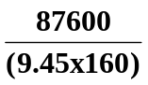
ΔT = 110 – (-50)
= 160 ⁰C c = 57.9 J kg⁻¹ K⁻¹ [1 mark]

Q = Pt
= 365 x 240
= 87600 J

[1 mark]

2. [14 marks]
In an investigation, students were asked to find the value of the resistance of a device in a circuit. The table shows the students’ results.
Potential difference (V) | 1.2 | 1.8 | 2.2 | 3.0 | 3.4 | 3.7 | 4.2 | 4.8
Current (mA) | 140 | 210 | 256 | 350 | 410 | 430 | 490 | 560

- Using correct symbols draw a circuit diagram to show a simple experimental setup the students were likely to have used to have attained the data above. (2 marks)
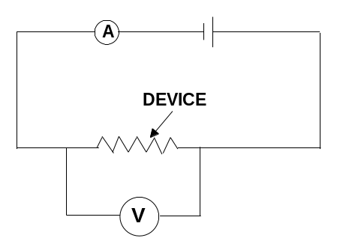
NB: The new symbol for
Resistance is soon to
be a rectangle so either
symbol is acceptable.

- Graph the data on the axes below and comment on what information the shape of the graph provides. (Current on the x-axis) (4 marks)

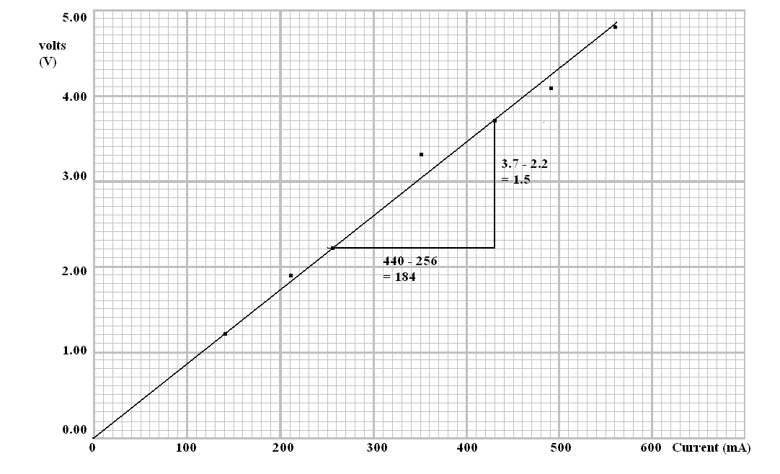
Graph marks:
Axis – 1 mark
Labels – 1 mark
Points – 1 mark
Line of best fit
- 1 mark

- Using the graph, calculate the gradient of the line. (2 marks)

Gradient = 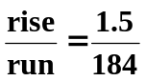 as shown on the graph above [1 mark]
Gradient = 1.5 ÷0.185
= 8.1 Ω [1 mark]

- What does the gradient represent? The resistance value [1 mark]

- Would it be safe to assume that the resistance of the circuit would remain constant above 5.0 V? Explain. (2 marks)

No. There is a low value for the resistance so if the voltage is increased then the current would increase and the circuit could become hot. Increased temperature would increase resistance.

OR

Yes, given the linear nature of this data. If 5V was used and the circuit was switched on for a short period of time.

- If the battery stores 1.00 x 10² C of charge and using your graph to determine current flow, how long will the circuit operate at 4.0 V. (3 marks)

For 4V, I = 0.460 A q = It
(‘I’ must be from graph) 100 = 0.460 x t [1 mark]
q = 100.0 C t = 100 ÷ 0.460
t = 217.39 s
[1 mark] = 217 s [1 mark]

3. [15 marks]

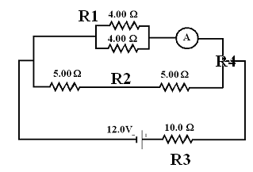
Two students have set up a circuit for an investigation. The circuit diagram to the right shows a battery connected to a number of resistors.

- Calculate the total circuit resistance.
(3 marks)

R1 = (4⁻¹ + 4⁻¹)
= 2 Ω

R2 = 5 + 5 = 10 Ω [1 mark]

R4 = (2⁻¹ + 10⁻¹)
= 1.6667 Ω [1 mark]

R(total) = 10 + 1.6667
R_{T} = 11.7 Ω [1 mark]

- Calculate the total current through the circuit. (2 marks)

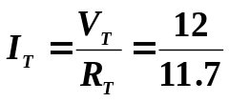 [1 mark]
I_{T} = 1.0286 A [1 mark]

- Calculate the potential difference across the 10.0 Ω resistor. (2 marks)

R₃ = 10 Ω V = IR
I_{T} = 1.0286 A = 1.0286 x 10 [1 mark]
V_{10Ω} = 10.286 V [1 mark]

- Calculate the potential difference across one of the 5.00 Ω resistors. (2 marks)

V across both 5Ω resistors = 12.0 – 10.286
= 1.714 V [1 mark]

As each resistor has half the potential difference,

V for one 5Ω resistor = 1.714 ÷ 2
= 0.857 V [1 mark]

- What is the reading on the ammeter? (3 marks)

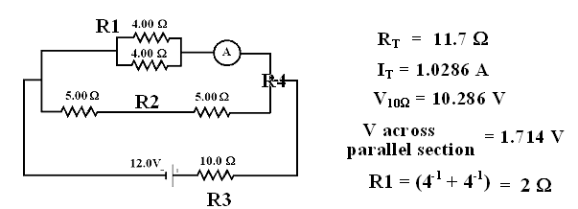

From the above data

R (4 Ω parallel section) = 2.0 Ω
V (4 Ω parallel section) = 1.714 V [1 mark]

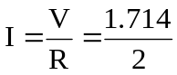 [1 mark]

I = 0.857 A

So ammeter = 0.857 A [1 mark]

- If the 4.00 Ω resistors were connected in series rather than in parallel, would the reading on the ammeter increase, decrease or stay the same? Without any calculations, explain your answer.
(3 marks)

DECREASE [1 mark]
Current is inversely proportional to resistance therefore increase resistance and current decreases. [1 mark]
When 4.0 Ω resistor put in series total resistance goes from 2.0 Ω to 8.0 Ω, as resistance has increased, current has decreased so metre reads less. [1 mark]

4. [14 marks]
The resistance is the measure of how much ‘friction’ a conductor presents to an electric current. Consider the factors that affect resistance:
- Length (l). It is found that resistance increases proportionately with the length of a conductor
e.g. R ∝ l
- Cross-sectional area (A). The greater the cross-sectional area of a conductor, the smaller its resistance. e.g. R ∝ 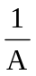
- Resistivity of the material (ρ - pronounced ‘rho’). An electrical property of materials is their resistivity. The resistance of a conductor is proportional to its resistivity; e.g. R ∝ ρ

These relationships can be combined as follows:

R = ρ l where R = resistance in ohms (Ω)
A ρ = resistivity in ohm metres (Ωm)
l = length in metres (m)
A = cross-sectional area in square metres (m²)

A group of students were investigating the change in resistance of a metallic wire with a cross-sectional area of 1.257 x 10⁻⁷ m² against the length of wire used. They set up a circuit with a constant 12.0 V and measured the current in 0.25 m of the wire. They then increased the length of the wire from 25 cm to 100 cm in 25 cm increments and again measured the current.

- For this investigation name the:
  - independent variable. Length of wire (1 mark)
  - dependent variable. Current (1 mark)
  - two control variables. Same PD, same diameter of wire, same material, etc (2 marks)
- Write an appropriate hypothesis for this experiment. (2 marks)

As the length of the wire is increased then the current of the wire decreases.
[1 mark answer with no ratio]

As the length of the wire is increased doubled, then the current of the wire decreases by half.
[2 mark answer with ratio]

- The data they collected is shown below. Complete column three of the table to show the resistance of the wire at various lengths. (3 marks)

Length (m) | Current (A) | Calculated resistance (Ω)
0.25 | 0.060 | R = 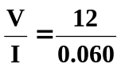 = 200
0.50 | 0.030 | 400
0.75 | 0.020 | 600
1.00 | 0.015 | 800
- Calculate the resistivity of one line of data, show your working below. (2 marks)

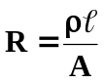
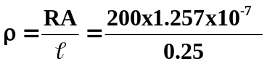 [1 mark]
= 1.0056 x 10⁻⁴ Ωm [1 mark]

- If the radius of the wire was doubled, would the value of the resistance
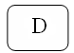
    - double
    - say the same
    - halve
    - quarter answer (1 marks)

- If the resistance of the wire was doubled, with the resistivity

    - double
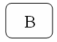
    - say the same
    - halve
    - quarter answer (1 marks)

g. if the length of the wire was halved, with the resistance

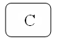
- double
- say the same
- halve
- quarter answer (1 marks)

5. [10 marks]
Read the following information was taken from Physics – Revealing Our World by Christina Hart.

Recollections by Mrs B. Malone …
The time came when we learned that we were to move to the big city. We younger children had never been to Melbourne, and I think we were very excited about it all….

Our Melbourne home was equipped with electricity for lighting and gas for cooking, heating, etc. – real progress. Some homes were still lit by gas mantels, gas stoves replaced the wood-fuelled ones (which had made kitchens so hot in summer) and small gas-heated water cisterns appeared on kitchen walls to service the sink. Washing was speeded up in gas-heated coppers and gas fires replaced the cheerful (but yet wasteful) wood fires in open fireplaces. Electricity was gradually appearing on the scene, but until probably well into the 1920s the normal suburban household was equipped with only one power point – usually for the electric iron. The socket had two holes only (no earth). When we first moved into our house, our mother was proudly showing us where the wonderful new electric iron was to be connected, by touching the socket with two of her fingers: only to give herself a hefty electric shock!

There were still no vacuum cleaners, etc. The first electrical kitchen aids were probably the electric iron and toaster, and a small one-bar radiator. In boarding houses double adapters boomed. Fitted into the central hanging light socket, one could connect a radiator or toaster, as long as the landlady was not about to call in! With the advent of other electrical implements, electricians must have reaped a small fortune rewiring houses and installing power points in every room.

- Up until the 1920s, most homes only had one power point. What was this usually used for?
Electric iron [1 mark]
- Early electrical homes had no earth wire. What is the purpose of an earth wire?

The earth wire is designed to carry away excess current from appliances for example in the case of a short circuit. [1 mark]
Designed to prevent current flowing through people. [1 mark]

- Many appliances today such as hairdryers don’t have an earth connection. Explain how are these appliances are made safe?

Double insulation. [1 mark]
Not only are all internal conductors insulated with plastic, but appliance is also covered in plastic insulation – two layers of plastic so double insulation. [2 marks]

- Name one electrical safety device in the home and explain how it works. (3 marks)
Student could discuss fuses, circuit breakers or RCD. For each, 1 mark for name and 2 marks for a suitable explanation of how the device works. For example:

FUSE:
Excess current causes wire to melt so circuit breaks and no current to cause damage. Wire must be replaced with similar type of fuse wire.

CIRCUIT BREAKER:
Excess current causes electromagnetic switch to turn off and so breaks the circuit. No circuit so no current to cause damage. Need to push switch back on once problem fixed.

- Modern homes have many power points and light switches. Often, one light can be controlled by two switches.

In the diagram below, is the light from the two-way switch on or off? OFF (1 mark)

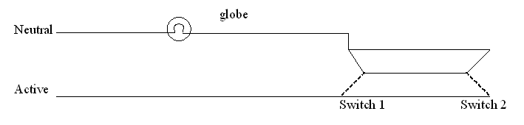

Section three: Comprehension 11 marks
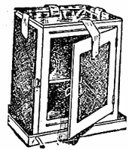
This section has one (1) question. Answer in the spaces provided.

The Coolgardie Safe
Storing perishable food was a constant problem in the days before refrigeration. The first home refrigerators arrived in 1927. Until this time food was either kept cool with ice and Coolgardie Safes, or preserved, salted or cured. The original inventor of the Coolgardie safe is unknown, however its birthplace has been attributed to the Western Australian town of Coolgardie. The cooling device began showing up in homes around the 19th century, and variations of the safe remained as a household item until the 1920s.
. Image reference:
http://www.citymuseummelbourne.org/Level3/cooldoc/cool.html

The Coolgardie Safe was designed to store meat and other foods, which required from protection from the heat of the Australian summer. The Coolgardie safe was made from a simple wooden frame, fitted with shelves and with the doors, sides and rear completely covered with hessian. A deep iron tray, kept filled with water, stood on top, and a larger tray stood under the safe’s short legs. Strips of flannel cloth dipped in the water and hanging against the hessian kept it wet as evaporation occurred. The safe was always kept outside in a shaded, breezy spot.
The following is the childhood memories of one Coolgardie Resident.

“In our garden grew a fine cypress tree with branches admirably arranged for climbing. This tree also sheltered the Coolgardie safe which was such a necessarily in the summer - we had no ice or refrigerators in those days. When we children were sent out to bring in milk or butter from this safe it was almost a physical impossibility to refrain from scooping a fingerful or two of luscious yellow clotted cream setting in its wide, shallow dish - but the path made by the finger would never join up again. The punishment could be a week long chore of keeping the safe’s reservoir filled with water so that the hessian sides never dried out.”

- The article talks about the “heat of the Australian summer” when they were referring to how high the temperature was. Explain the difference between heat and temperature. (2 marks)

- Heat is the transfer of energy from an object at a higher temperature to one at a lower temperature until thermal equilibrium is reached.

- Temperature is a measure of the average kinetic energy of an object.

- Imagine that the housewife, after milking the cows, had made butter. If there was 600 g of butter (specific heat 1.26 x 10³ J kg⁻¹ K⁻¹) and 1.2 L of milk (3.77 x 10³ J kg⁻¹ K⁻¹), both at 35⁰C how much energy would the Coolgardie safe have had to remove so they were both at a temperature of 15.0⁰C?
(3 marks)
Conversions – [1 mark]

Q = mcΔT (milk) + mcΔT (butter)
Q = (1.2 x 3770 x 20) + (0.6 x 1260 x 20) [1 mark]
Q = 90480 + 15120
Q = 105600

Q = 1.06 x 10⁵ J [1 mark]

- Name the main physics principle that helped keep the food cold in the Coolgardie safe.
Evaporation [1 mark]
- Explain fully, using physics principles and terminology, how the Coolgardie safe worked. (3 marks)

  - Water on hessian cloth evaporates
  - Phase change which needs energy
  - Energy taken from air inside safe and also from food so food cools.

e. Why was the safe kept in a shady, breezy spot outside the house, rather than inside the house where it
was more convenient? Fully explain. (2 marks)

Breeze – increases evaporation as evaporated water vapour removed [1 mark]

Shade – prevents safe and food becoming too hot with greater ΔT so more energy needed to be remove also prevents too rapid a loss of water so that it needs to be refilled constantly.
[1 mark]

End of Examination

